Project Development PHASE SPRINT-2

|  |  |
| --- | --- |
| **Team ID** | **PNT2022TMID08113** |
| **Project Name** | **Project – Retail Store Stock Inventory Analytics** |

SPRINT-2:

Data Exploration

DATA EXPLORATION

* Download and Load the Dataset
* Sales by Year
* Price by Year
* Stock by Year
* Sales by M_Data colored by M_Data
* Stock by M_Data colored by M_Data
* Price by M_Data colored by M_Data
* Sales Sunburst
* Stock Summary
* Price Sunburst
* Year hierarchy colored by Year and sized by top 10 Sales
* Stock and Sales for M_Data colored by M_Data
* Top 10 Stock for Year hierarchy
* Wordcloud for Year sized by Sales
* Revenue by Year
* Revenue by M_Data colored by M_Data

DATA COLLECTION:

1. **Download the dataset**

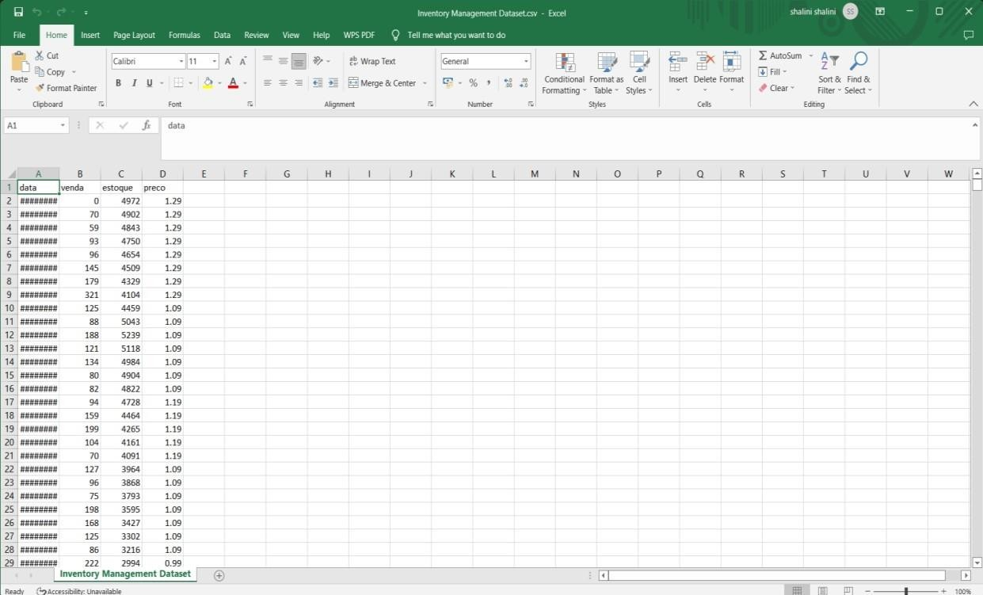

1. **Loading the dataset**

Tool Used – IBM Cognos Analytics

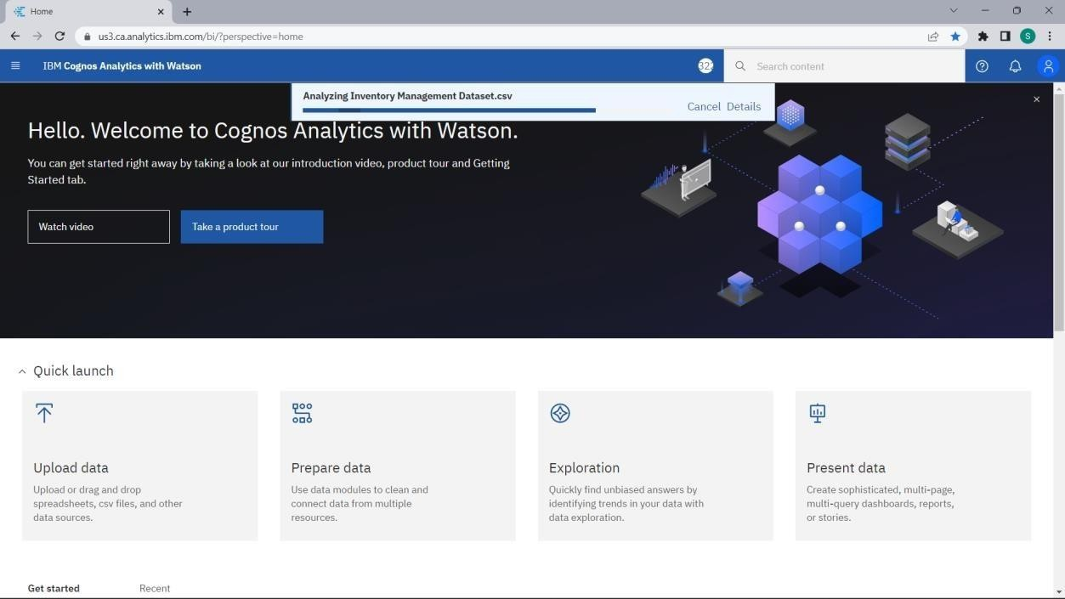

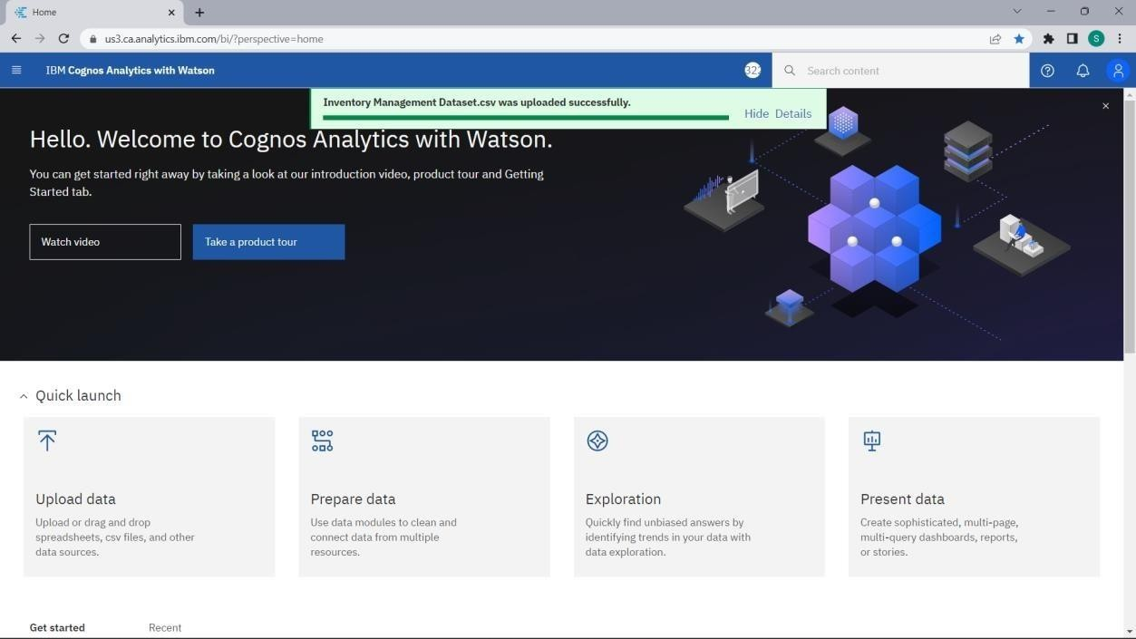

DATA EXPLORATION:

1. **Sales by Year:**

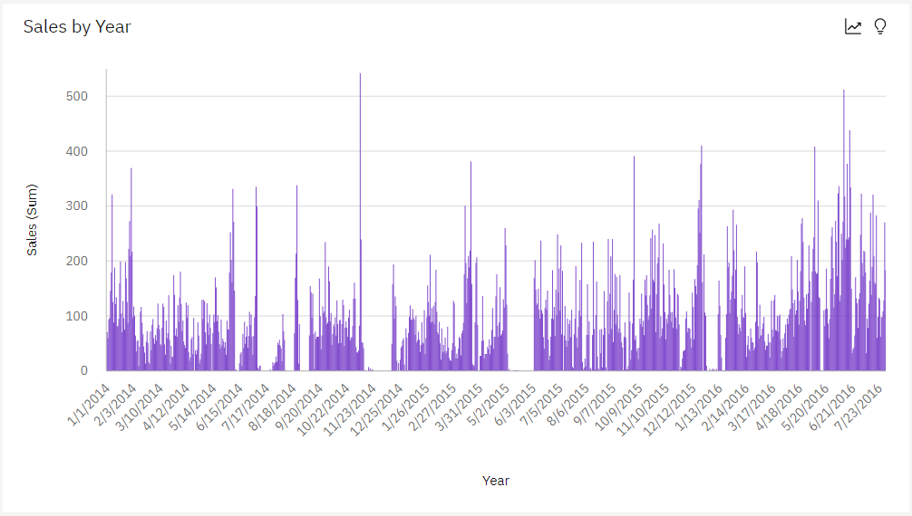

1. **Price by Year:**

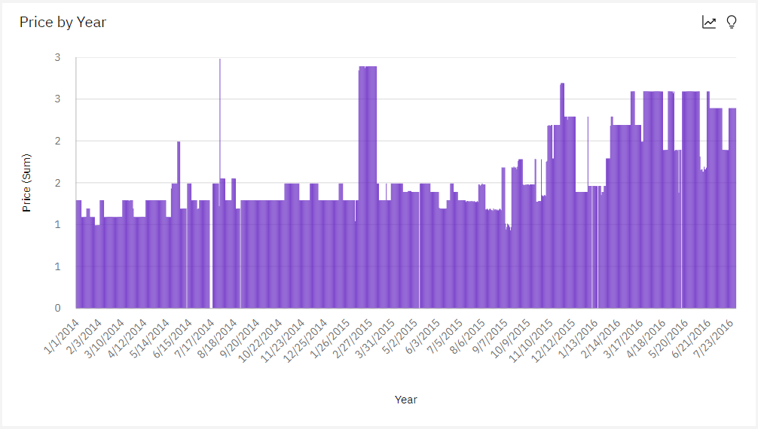

1. 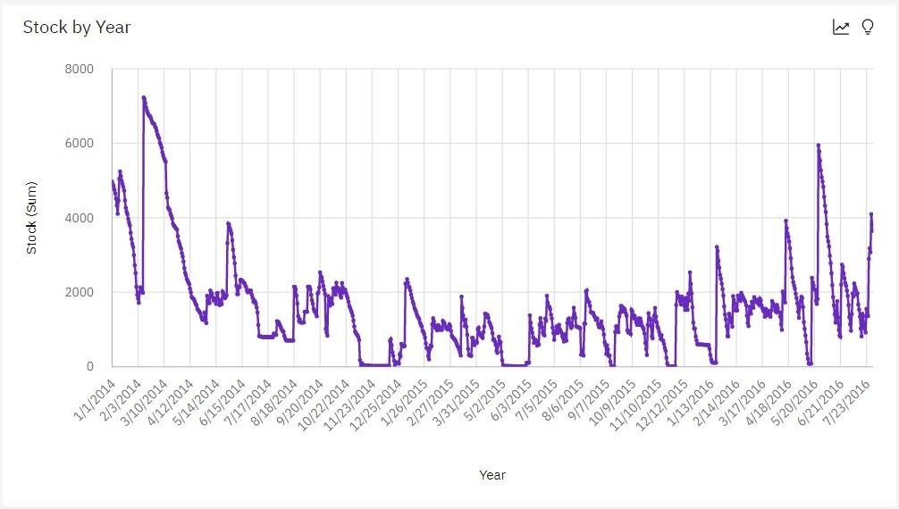**Stock by Year:**
2. **Sales by M_Data colored by M_Data:**

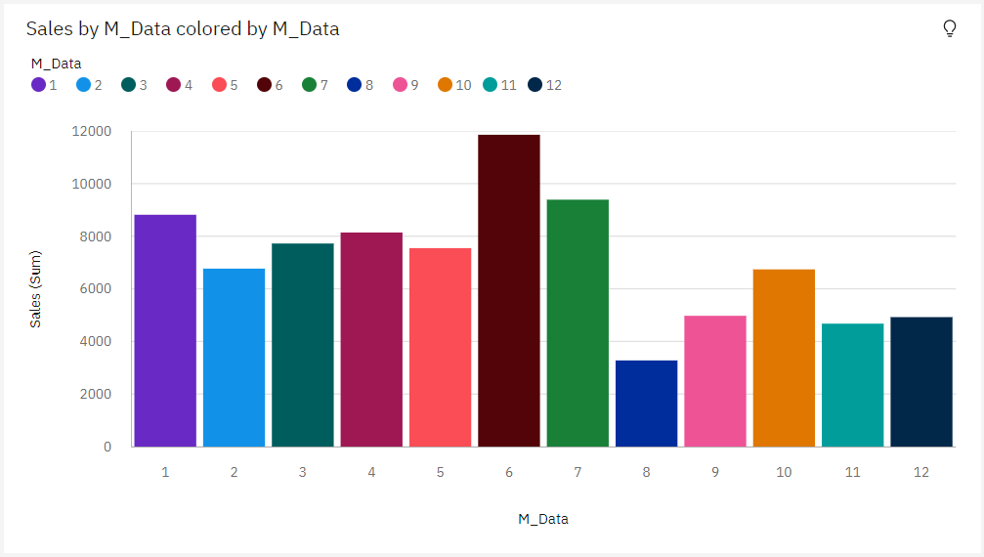

1. 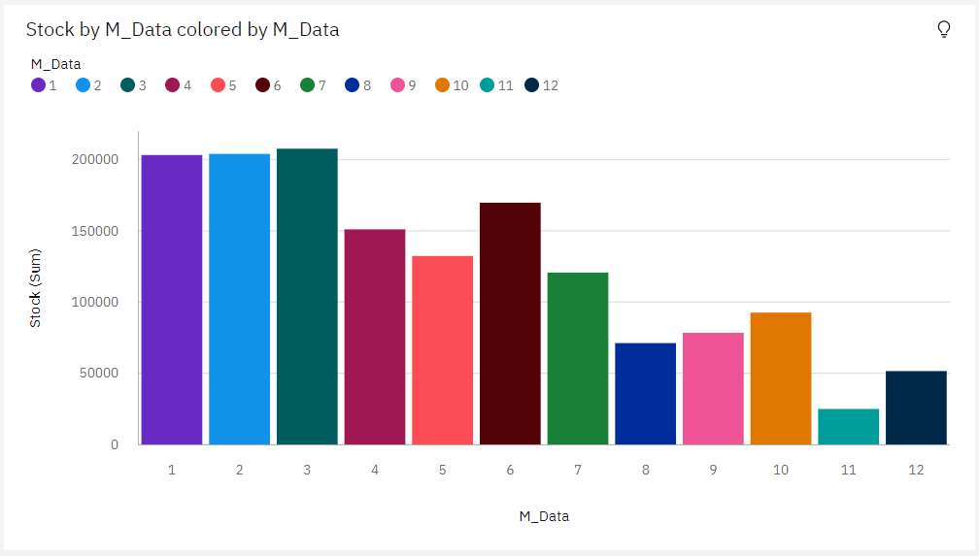**Stock by M_Data colored by M_Data:**
2. **Price by M_Data colored by M_Data:**

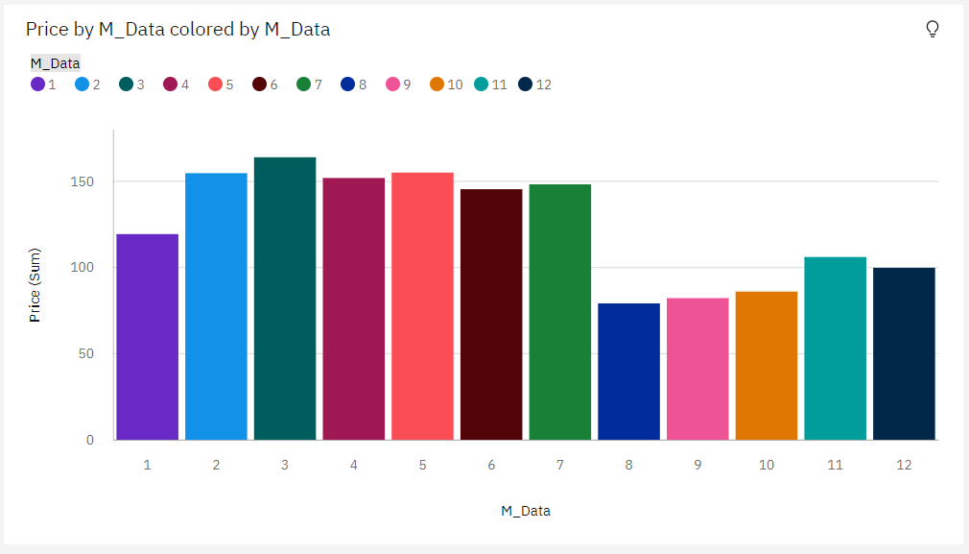

1. 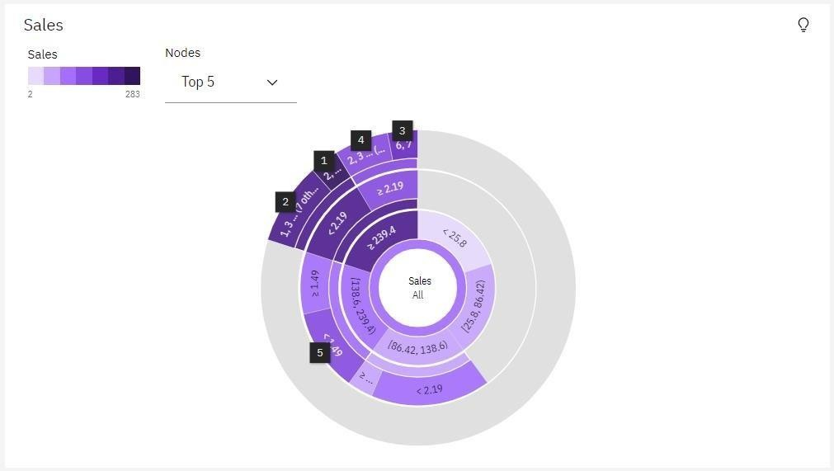**Sales Sunburst:**
2. **Stock Summary:**

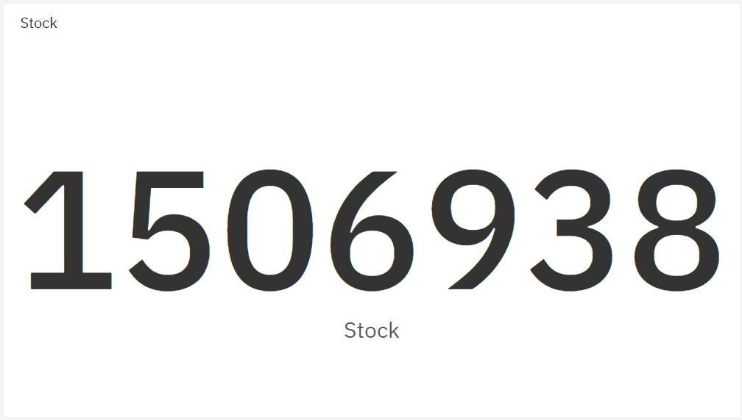

1. 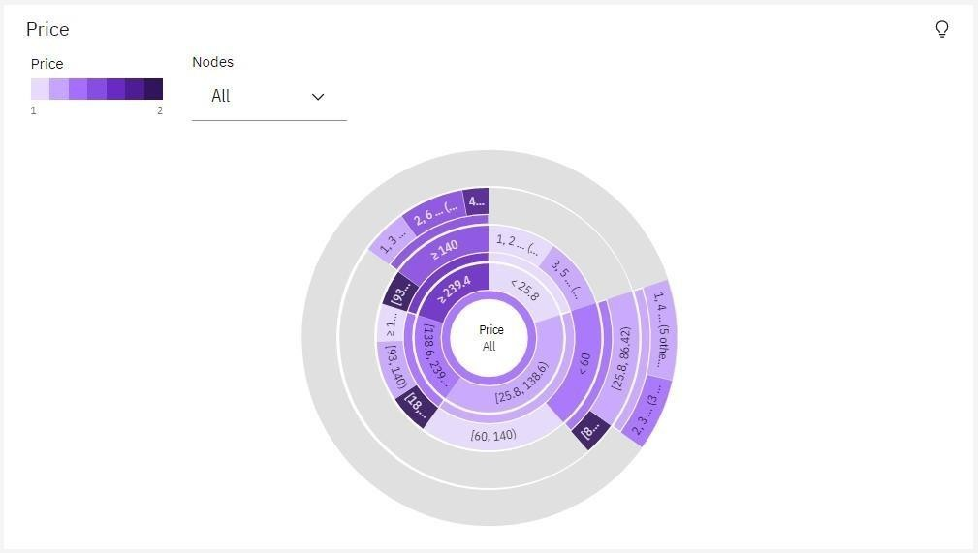**Price Sunburst:**
2. **Year hierarchy colored by Year and sized by top 10 Sales:**

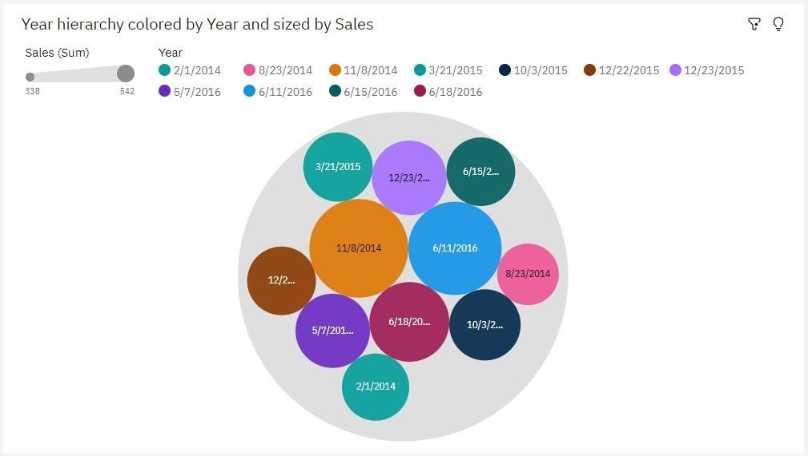

1. 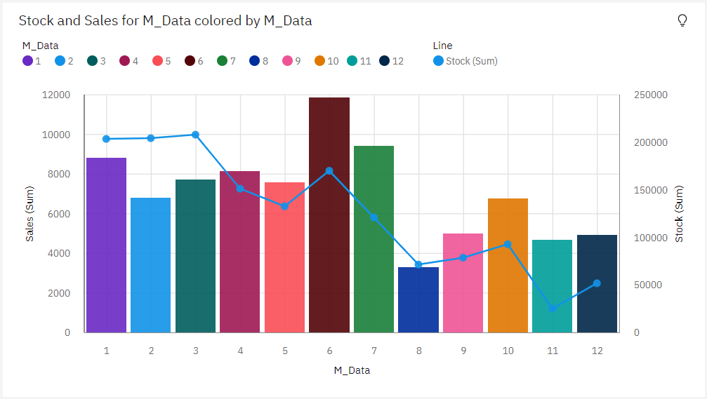**Stock and Sales for M_Data colored by M_Data:**
2. **Top 10 Stock for Year hierarchy:**

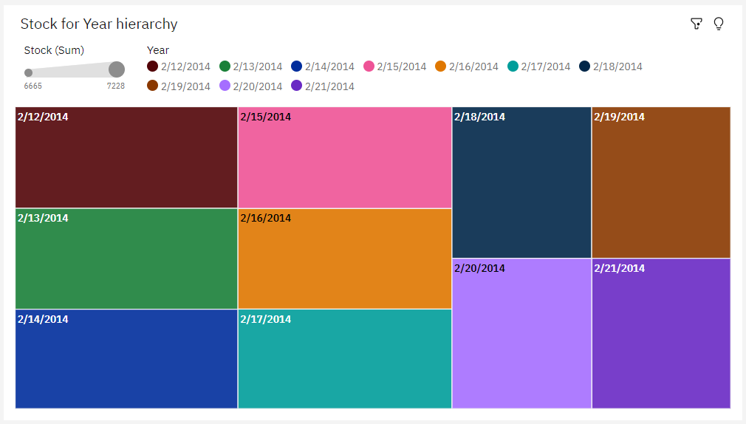

1. 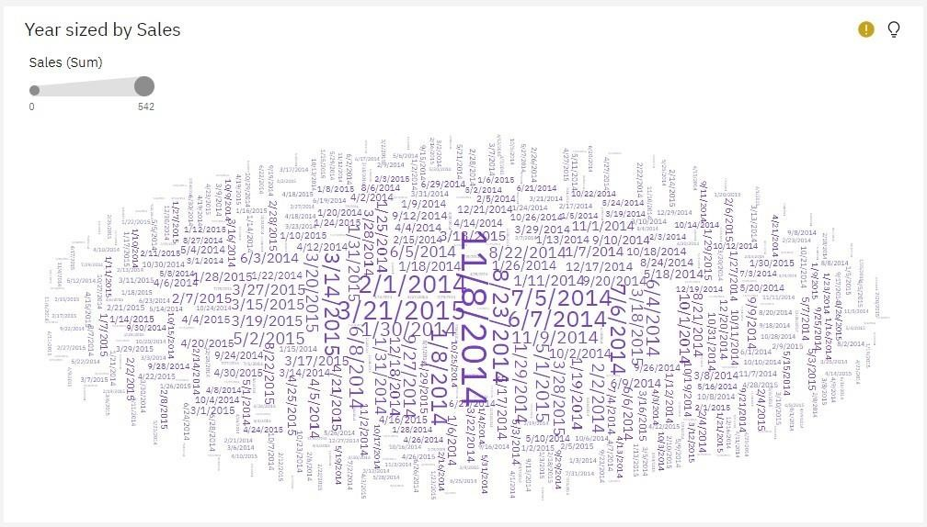**Wordcloud for Year sized by Sales:**
2. **Revenue by Year:**

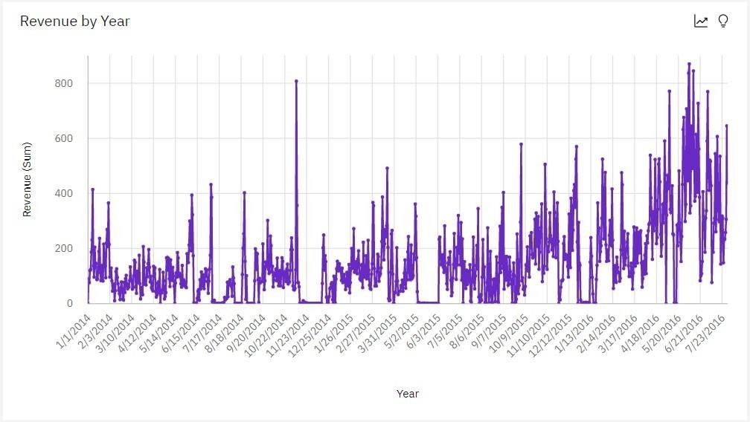

1. 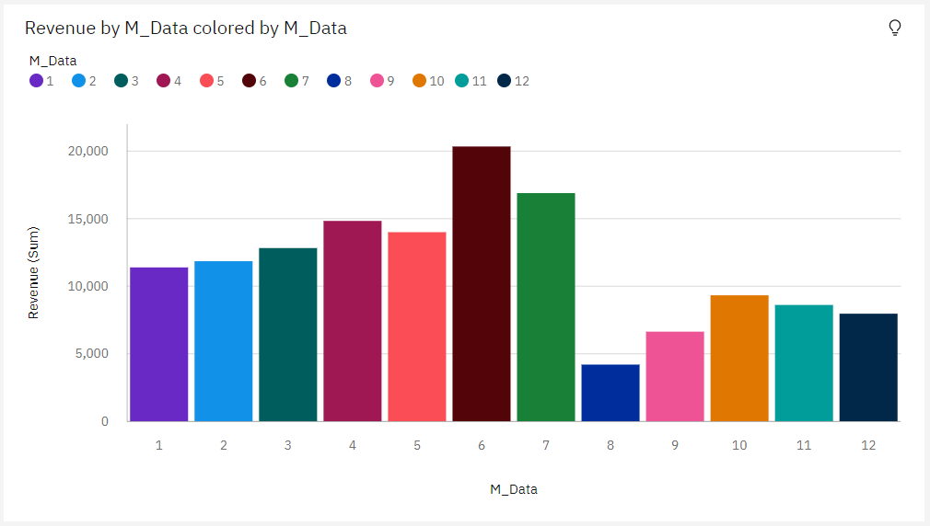**Revenue by M_Data colored by M_Data:**